Chicken stock 
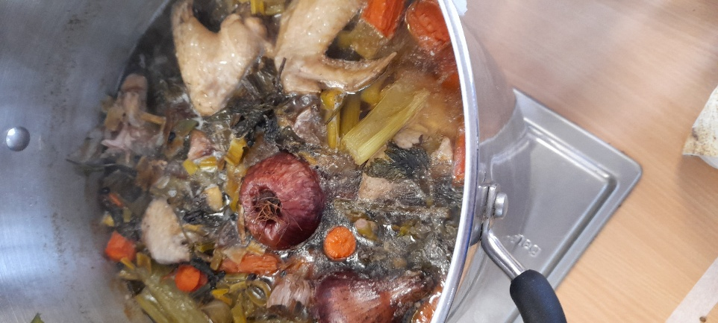

Recipe source: Sandra bernard
Season: all seasons
Type: stock, base soup
Difficulty: easy
Serves: Serves 30 to taste
Fresh from the garden: herbs, carrots, leek

Equipment | Ingredients:
  - Large stock pot
  - Chopping board
  - Chef knife
  - Vegetable peeler
  - Wooden spoon
  - Fine strainer or sieve
  - Large bowl or container
  - Ladle
  - 600gr chicken bones
  - 3 lt water
  - ½ onion picked with cloves
  - 50gr leek
  - 1 stalk celery cut in 8
  - 3 garlic clove with skin on cut 1/2
  - 6 bay leaves
  - 3 sprigs thyme
  - 3 sprigs parsley
  - 2gr whole pepper

What to do:

- Chop the bones into 10cm pieces and blanch starting in cold water. Refresh.
- Place the blanched bones into a suitable sized clean pot, add the water, making sure it completely covers the bones.
- Bring the pot to the boil, turn down to a slow simmer and skim well.
- Clean and wash the vegetables and cut them into a Mirepoix. Add the Mirepoix to the pot along with the herbs and spices.
- Simmer for 3-4 hours, skimming the surface as often as necessary. If the water level evaporates below the level of the bones top up with fresh water.
- At the end of the cooking time, taste, and season as necessary and allow to simmer for a further five minutes.
- Strain the stock through a fine strainer into a suitable clean container and cool before refrigerating.

