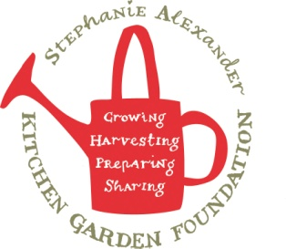
Warrigal Greens and salt bush & Cheese scrolls
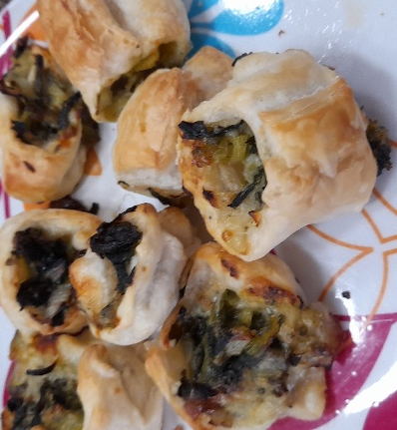

Recipe source: sandra
Season: all seasons
Type: snack, meal
Difficulty: easy
Serves: Serves 12-14 scrolls
Fresh from the garden: warrigal greens, spring onion, salt bush

Equipment | Ingredients: x2 sheets
  - Large mixing bowl
  - Measuring spoons
  - Chopping board
  - Chef's knife
  - Baking tray or roasting tray
  - Baking paper
  - Pastry brush
  - Tongs
  - Oven mitts
  - 1 sheet ready-made puff pastry (replace with GF puff pastry* *it contains egg and soy*)
  - 1 cup chopped Warrigal greens, other green leaf
  - 1 spring onion sliced
  - 1 tsp salt bush
  - 1 cup grated cheese (replace with DF cheese)
  - 1 egg, beaten (replace with milk / soy milk)

What to do:
- Preheat the oven to 190°C.
- Blanch the Warrigal greens in boiling water for 1 minute , then drain well. Add spring onion and other vegetables leaf.
- Lay the puff pastry flat on a clean surface.
- Sprinkle the pastry evenly with grated cheese and the drained greens mixture.
- Roll the pastry tightly into a log.
- Slice into 2 cm rounds.
- Place the scrolls on a lined baking tray and brush the tops with beaten egg.
- Bake for 20 minutes, or until golden and cooked through.
Native ingredients
Warrigal Greens (Tetragonia tetragonioides) are Australia's native spinach. They have traditionally been eaten by Aboriginal peoples and are rich in vitamins and minerals. Because the leaves naturally contain oxalates, they should be blanched before eating to improve flavour and reduce the oxalate content.
Old Man Saltbush (Atriplex nummularia) is another Australian native edible plant. Its silvery leaves have a naturally salty flavour, making it an excellent substitute for table salt. Using dried saltbush harvested from the school garden introduces students to Indigenous bush foods while reducing the need for added salt

Allergen Notes
- Gluten: ❌ Contains wheat (puff pastry)
- Dairy: ❌ Contains cheese
- Eggs: ❌ Contains egg
- Nut-free: ✅ No nuts included

