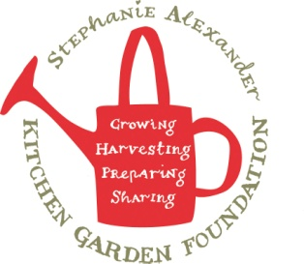
Wattleseed apple crumble
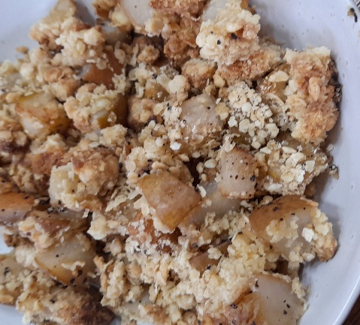

Recipe source: Sandra
Season: Autumn
Type:
Difficulty:
Serves: Serves 30 to taste
Fresh from the garden: Lemon, apples,

Equipment | Ingredients:
  - Vegetable peeler
  - Apple corer or knife
  - Chopping board
  - Mixing bowl
  - Measuring cups and spoons
  - Baking dish (20–22 cm)
  - Spoon or spatula
  - Oven mitts
  - 6 apples peeled and sliced / diced
  - ½ lemon juice
  - 1,5 tbsp sugar
  - 1 tsp ground wattleseed
  Crumb topping:
  - 1.5 cup rolled oats (replace GF oat)
  - 1.5 cup plain flour (replace GF flour)
  - ¾ cup brown sugar
  - 150gr melted butter (replace with nutelex)

What to do:
- Preheat oven to 180°C.
- Mix apples, sugar and wattleseed in a baking dish.
- Combine oats, flour, brown sugar and melted butter.
- Sprinkle evenly over the apples.
- Bake for 35–40 minutes, or until the topping is golden and the apples are tender.
- Allow to cool for 10 minutes before serving.

Native ingredient
Wattleseed is a traditional Australian bush food with a rich roasted flavour, often described as having notes of coffee, hazelnut and chocolate. It adds a unique Australian flavour to both sweet and savoury dishes.
Allergen Notes
- Gluten: ❌ Contains wheat flour and oat
- Dairy: ❌ Contains butter
- Eggs: ✅ Egg-free
- Nut-free: ✅ Wattleseed is not a tree nut (safe for most nut-free diets unless otherwise advised)

