
Sweet potato and orange salad
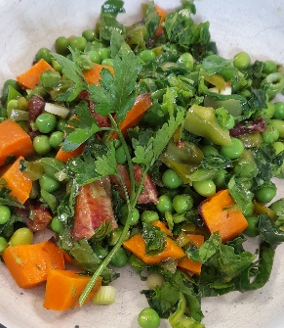

Recipe source: sandra
Season: spring/summer
Type:salad
Difficulty: easy
Serves: Serves 30 to taste
Fresh from the garden: spinach, kale, sweet potato, spring onions, herbs

Equipment | Ingredients:
  - Bowl
  - Chopping board
  - Knife
  - Measuring cup and spoons
  - Colander
  - Baking tray
  - Baking paper /mat
  - Mixing bowl
  - Whisk
  - Salad or bowl for serving
  For the Roasted Vegetables:
  - 4 sweet potatoes peeled and diced
  - 1 tbsp extra virgin olive olive oil sprayed
  - 2 pinch salt
  - 3 red peppers
  For the Salad:
  - 100gr Edamame beans
  - 1-2 oranges peeled and cut in segment
  - 2 cup frozen peas (thawed)
  - 1 bunch kale finely chopped
  - 1 cup spinach finely chopped
  - 2 drizzle extra virgin olive oil
  - 2 pinch salt
  - 4 green onions whites and green parts chopped small
  For the Dressing:
  - 4 tbsp fresh mint leaves
  - 4 tbsp fresh coriander leaves and stems
  - 4 tbsp olive oil
  - 1 lemon juiced
  - 4 limes juiced
  - 4 tbsp pure maple syrup / honey
  - 0.5 tsp salt

What to do:
- Preheat the oven to 200°C.
- Wash, peel and dice the sweet potato.
- Cut the capsicums into small pieces.
- Place the sweet potato and capsicum on a baking tray. Add a little olive oil and salt.
- Roast for 20–25 minutes, until the sweet potato is soft. Allow to cool.
- Bring a saucepan of water to the boil.
- Add the edamame and peas and blanch for about 1 minute, until bright green.
- Drain and rinse under cold water to stop the cooking.
- Wash and chop the kale and spinach
- Peel the oranges and separate into segments.
- Thinly slice the green onions.
- Make the dressing by whisking together the olive oil, lemon juice, lime juice, maple syrup and salt.
- Add the sweet potato, capsicum, snow peas, peas, mandarins, green onions and herbs to the kale.
- Pour over the dressing and gently toss everything together.
- Serve fresh and enjoy!

