
Sri Lankan Rolls
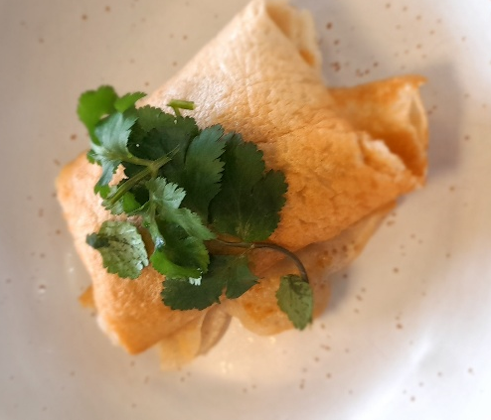

Recipe source: Sandra bernard
Season: all seasons
Type: main dish
Difficulty: easy
Serves: Serves 30 to taste
Fresh from the garden: coriander, carrots, potatoes

Equipment | Ingredients:
  - Chopping board
  - Chef’s knife
  - Large bowl
  - Jug or bowl (for batter wet ingredients)
  - Whisk
  - Large frying pan
  - Crepe pan or non-stick frying pan
  - Tongs
  - Baking paper and tray
  - Shallow bowls (for crumbing)
  - frying pan
  - Wire rack and tray
  Crepes
  - 300g plain flour
  - large pinch sea salt, to season
  - 80g butter, melted
  - 3 eggs, beaten
  - 125ml milk
  - 300ml water
  Potato filling
  - 3 medium potatoes, cubed
  - 2 carrots diced
  - 1 brown onion, finely diced
  - 1 tbsp oil
  - 1 cinnamon stick
  - 2 sprigs curry leaves
  - thumb-sized piece fresh ginger, finely grated
  - 2 cloves garlic, finely grated
  - ½ tsp turmeric
  - 1 tsp each chilli powder, ground coriander, ground cumin
  - 2 tbsp tomato ketchup
  - 30ml water
  - 1 tsp brown sugar
  - lemon juice, to taste
  - sea salt, to season
  - lemon wedges and spicy tomato chutney, to serve
  Crumb coat
  - 3 egg whites, lightly whisked
  - 1 cup breadcrumbs
  - oil for frying

What to do:
Make crepe batter
- Combine the flour and salt in a large bowl.
- Whisk the butter, eggs, milk and water together in a jug or bowl, then gradually whisk into the flour to make a thin batter (add more water if needed so it spreads easily in the pan).
- Rest batter for 1 hour.
Prep the filling
- Boil the potatoes in salted water for about 8 minutes until just tender. Drain and set aside.
- Heat the oil in a large frying pan over medium heat. Saute the onion and carrots until softened.
- Add cinnamon stick, curry leaves, ginger and garlic. Cook for 1 minute until fragrant.
- Add the potatoes, crush lightly in the pan with a spoon, cook for 1 minute. Pour in 30ml water to deglaze frond (browned bits) from the base of the pan.
- Stir in turmeric, chilli powder, ground coriander, ground cumin, tomato ketchup, and sugar. Cook for 1–2 minutes until well combined.
- Stir in lemon juice and sea salt to taste, then remove from the heat. Remove the cinnamon stick.
Cook and fill crepes
- Heat a crepe pan over medium. Pour 60ml of the batter into the pan and swirl to make a thin circle.
- Cook for 30 seconds, flip, cook for 15 seconds more. Transfer to a tray lined with baking paper and repeat with remaining batter.
- Divide the filling into 8 portions, then place down the centre of each crepe in a log shape, leaving a border on the sides to fold in.
- Fold over the edge closest to you to enclose the filling, then fold in each side and continue to roll up to enclose.
- Place the egg whites in a shallow bowl and the breadcrumbs in a shallow tray.
- Dip each crepe roll in the egg whites, then roll in the breadcrumbs to completely coat.
Fry and serve
- Heat enough oil in a frying pan
- Shallow fry the rolls in batches for 2-4 minutes, until dark golden and crisp. Drain on a wire rack over a tray, cut them ¼ then serve with lemon wedges and spicy tomato chutney.

