
Masala Frittata
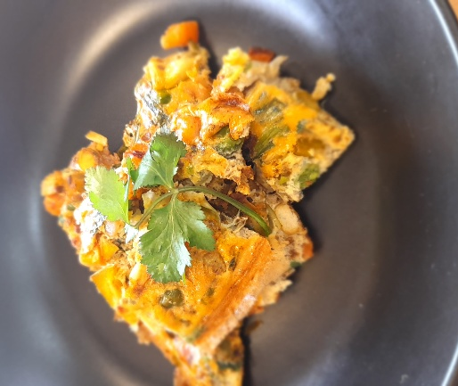

Recipe source: BBC Good Food
Season: Autumn / Winter
Type: egg-base meal
Difficulty: easy
Serves: Serves 30 to taste
Fresh from the garden: Coriander, tomato, leek, spring onions, greens

Equipment | Ingredients:
  - Large non-stick frying pan (ovenproof if possible)
  - Mixing bowls (2–3)
  - Chopping boards (colour coded)
  - Chef knives
  - Whisk or fork (for eggs)
  - Spatula
  - Measuring spoons
  - Serving plates or trays
  - 2 tbsp oil
  - 1 onion sliced
  - ½ leek sliced
  - 1 tbsp homemade Madras curry paste
  - 500gr tomato diced
  - Greens from garden (spinach, warrigal green) sliced
  - Frozen vegetables
  - ¼ tsp ground cinnamon
  - 1 red chilli finely chopped (if spicy)
  - Coriander chopped
  - 8 eggs beaten
  Curry paste (2-3 tbsp curry paste)
  - 3 tbsp cumin
  - seeds
  - 3 tbsp coriander seeds
  - 1 star anise
  - 1⁄2 tsp chilli powder
  - 4 tbsp garam masala
  - 4 black peppercorns
  - 1 tbsp ground turmeric
  - 1 tsp tamarind paste
  - 1 tbsp malt vinegar (use apple cider vinegar for GF)
  - 1 green chilli sliced
  - 1 bunch coriander chopped
  - 200g roasted peppers from a jar

What to do:
- step 1
Heat the oil in a medium non-stick, ovenproof frying pan. Tip in the sliced onions and leek and cook over a medium heat for about 10 mins until soft and golden. Add the Madras paste, ground cinnamon and frozen or fresh vegetables and fry for 1 min more, then tip in the tomatoes and the chilli (if used). Cook until the mixture is thick and the tomatoes have all burst.
- step 2
Heat the grill to high. Add half the coriander to the eggs and season, then pour over the spicy onion mixture. Stir gently once or twice, then cook over a low heat for 8-10 mins until almost set. Transfer to the grill for 3-5 mins until set.
For curry paste:
step 1
Toast all the spices in a frying pan, then leave to cool. Tip into a spice grinder and blend to a fine powder, then add the tamarind paste, vinegar, cinnamon stick, chilli, coriander and roasted peppers. Blend to a coarse paste, then transfer to a container.
⚠️ Allergen Card
Contains:
- Eggs
May contain (check ingredients):
- Curry paste (malt vinegar - Gluten)

