
Lemon Myrtle chicken tray
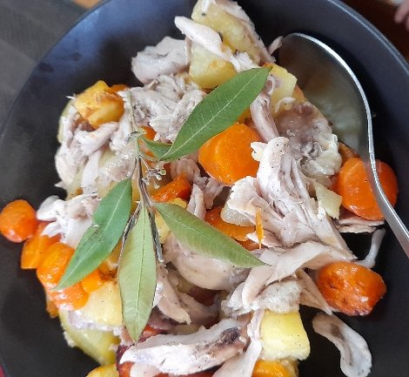

Recipe source: sandra
Season: all seasons
Type: Main meal
Difficulty: Easy
Serves: Serves 30 to taste
Fresh from the garden: Carrots, potatoes, spring onions

Equipment | Ingredients:
  - Large mixing bowl
  - Measuring spoons
  - Chopping board
  - Chef's knife
  - Baking tray or roasting tray
  - Baking paper
  - Tongs
  - Oven mitts
  - 1kg chicken drumsticks
  - 2 tbsp oil
  - 5gr lemon myrtle dried
  - 1 tsp garlic powder
  - 1tsp salt
  - 500gr diced potatoes
  - 2 carrots sliced

What to do:
- Preheat the oven to 200°C.
- In a large bowl, combine the olive oil, lemon myrtle, garlic powder and salt.
- Add the chicken, potatoes and carrots. Toss until evenly coated.
- Arrange the chicken and vegetables in a single layer on a baking tray.
- Bake for 45–50 minutes, or until the chicken is cooked through and the vegetables are tender and golden.
- Serve with a fresh green salad.
NOTES: chicken has been sous-viding cooking beforehand, we won’t need to bake for 50 minutes.

Sous-vide cooking technique:
- Preheat the sous-vide water bath to 65°C
- In a large bowl, combine the olive oil, dried lemon myrtle, garlic powder and salt.
- Coat the chicken evenly with the seasoning mixture.
- Place the seasoned chicken into vacuum-seal bags in a single layer. Vacuum seal each bag.
- Cook in the sous-vide water bath:
Chicken thighs: 65°C for 2½–3 hours
Chicken drumsticks: 74°C for 2–3 hours (helps tenderise meat around the bone)
- While the chicken is cooking, toss the potatoes and carrots with a little olive oil and season lightly with salt and pepper.
- Roast the vegetables on a lined baking tray at 200°C for 35–40 minutes, turning halfway, until golden and tender.
- Remove the chicken from the sous-vide bags and pat dry with paper towel.
- Place the chicken on a baking tray with the roasted vegetables and roast at 220°C for 8–10 minutes to brown and crisp the skin.
- Serve hot with the roasted vegetables and a fresh green salad.

Native Ingredient
Lemon Myrtle is an Australian native herb with a fresh citrus aroma and flavour. It adds a natural lemon taste without using fresh lemons and is widely used in Indigenous Australian cuisine

Allergen Notes
- Gluten: ✅ Gluten-free
- Dairy: ✅ Dairy-free
- Eggs: ✅ Egg-free
- Nut-free: ✅ Nut-free

