
Crispy Baked Polenta Fries
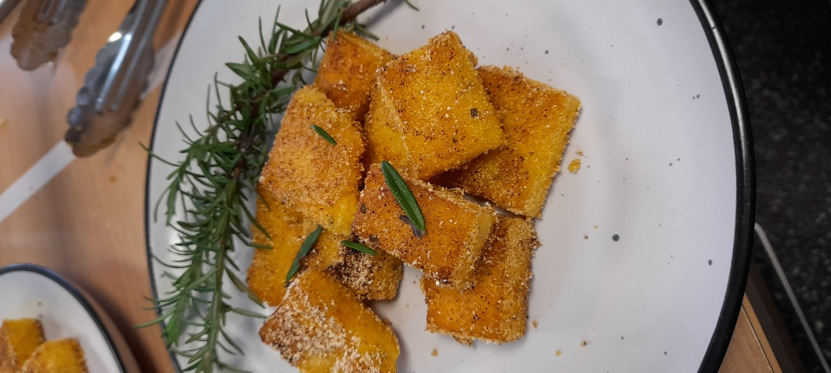

Recipe source: Sandra bernard
Season: any season
Type: side dish
Difficulty: easy-medium
Serves: Serves 30 to taste
Fresh from the garden: rosemary, herbs

Equipment | Ingredients:
  - Medium saucepan
  - Whisk or wooden spoon
  - Baking tray or slice tray
  - Baking paper
  - Knife
  - Oven trays
  - Pastry brush or oil spray
  - 500gr quick-cook polenta
  - 2lt stock
  - 3 tbsp olive oil
  - 2 tsp salt
  - Pepper to taste
  - 2-3 tbsp chopped rosemary
  Crunchy polenta crumb (after cooking)
  - 150gr dry polenta
  - 1tsp garlic powder
  - 1 tsp paprika
  - ¼ cup parmesan (replace with nutritional yeast for DF)

What to do:
Cook the polenta
- Bring water or stock to boil.
- Slowly whisk in polenta.
- Add herbs, salt, pepper and olive oil.
- Stir continuously until thick and smooth (3–5 minutes).
Set the polenta
- Pour into lined tray (~2 cm thick).
- Smooth surface.
- Cool completely.
- Refrigerate 1–2 hours until firm.
Cut fries
- Remove firm polenta from tray.
- Cut into fry shapes.

Crumb the fries
- Mix dry polenta crumb ingredients together.
- Lightly brush fries with oil.
- Roll fries in crumb mixture.
Bake
- Place fries on lined oven tray.
- Spray or drizzle lightly with oil.
- Bake at 220°C for 30–35 minutes.
- Turn halfway until golden and crispy.

Allergen Notes
- Gluten-free: ✅ Polenta is naturally gluten-free
- Dairy: ⚠️ Parmesan optional
- Egg-free: ✅
- Nut-free: ✅

