
Chinese, chicken & corn soup
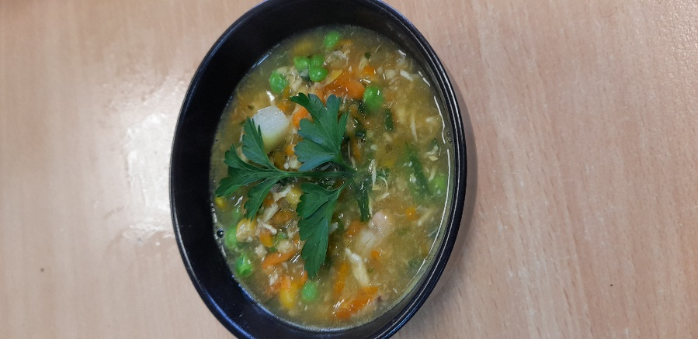

Recipe source: Sandra Bernard
Season: all seasons
Type: soup
Difficulty: easy
Serves: Serves 30 to taste
Fresh from the garden: Spring onion, chives, parsley, bak choy,

Equipment | Ingredients:
  - Large soup pot
  - Whisk
  - Measuring jug
  - Knife & chopping board
  - Ladle
  - 2 lt Chicken stock
  - 4 cans of creamed corn
  - 500gr cooked chicken (boiled in stock)
  - 4 tsp GF soy sauce
  - 4 tbsp Chinese cooking wine or mirin
  - 4tsp minced ginger
  - 5 grated carrots
  - Green vegetables from garden
  - Frozen pea
  - 4 cloves minced or 1 tbsp garlic (jar)
  - 4 tsp cornflour (GF) – make sure it is GF (mixed with a splash of cold water)
  - 1 bunch spring onion
  - Chive, parsley chopped
  - Salt and pepper to taste

What to do:

- Place broth, creamed corn, soy sauce, Chinese cooking wine, ginger, garlic and cornflour in a saucepan over high heat.
- Bring to boil, then turn down the heat to medium and stir occasionally. Cook for 5 minutes or until slightly thickened.
- Adjust seasoning with salt, Add the chicken, vegetables, season with white pepper, and serve, garnished with scallions.
⚠️ Allergy & Diet Information
Allergen Notes
- Gluten: ⚠️ Soy sauce may contain gluten (use GF tamari if needed), cornflour may contain gluten
- Egg-free: ✅
- Dairy-free: ✅
- Nut-free: ✅

