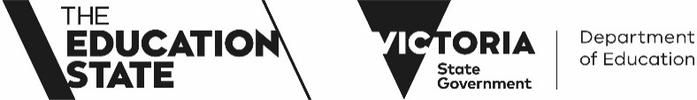

2025 Parent / Caregiver / Guardian Opinion Survey:
Our school is conducting the annual Parent / Caregiver / Guardian Opinion Survey offered by the Department of Education and is seeking your feedback. The survey is designed to assist schools in gaining an understanding of families’ perceptions of school climate, student behavior, and student engagement. The survey is optional, but we encourage and appreciate your participation.
Our school will use the survey results to assist in identifying areas for improvement and professional development needs in the school, to target school planning and improvement strategies.

The Parent / Caregiver / Guardian Opinion Survey will be open online from Monday 18 August to Friday 19 September 2025.
All families are invited to participate in the survey.

The survey will be conducted online, only takes 20 minutes to complete, and can be accessed at any convenient time on desktop computers, laptops, tablets or smartphones.

The online survey will be available in English and other languages for parents and caregivers who speak a language other than English at home.

Survey Link-
https://research.orima.com/parent

Your school’s generic PIN is:
217502
The survey results will be communicated to parents / caregivers / guardians through annual reporting in 2026.
Please speak to your child’s teacher if you would like more information.

