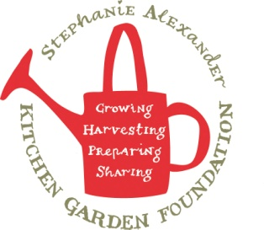
Bush tomato damper
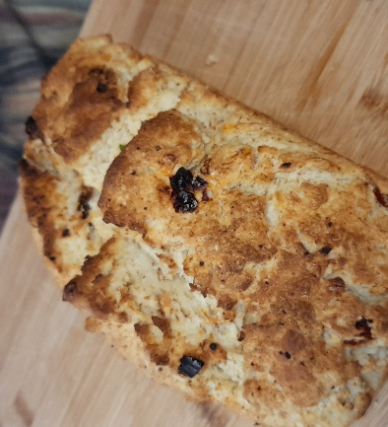

Recipe source: Sandra
Season: All seasons
Type: baking
Difficulty: easy / medium
Serves: Serves 30 to taste
Fresh from the garden: saltbush, thyme, rosemary, pasley, chive, spring onion

Equipment | Ingredients:
  - Large mixing bowl
  - Measuring cups and spoons
  - Knife and chopping board
  - Pastry cutter or butter knife (optional)
  - Baking tray
  - Baking paper
  - Cooling rack
  - Oven mitts
  - 3 cups self-raising flour or bread flour (Replace with GF flour)
  - ½ tsp salt and salt bush
  - 1 tsp dried bush tomato finely chopped
  - 6 or (20gr) semi-dried tomato cut ½ finely chopped
  - 30gr butter (Replace with oil)
  - 1 cup milk (Replace with water)
  - 1 tsp chopped thyme or rosemary
  Dip:
  - 100gr coconut yoghurt
  - ¼ tsp lemon myrtle
  - 1 tsp chive
  - 1 tsp parsley
  - ¼ sliced spring onion
  - ¼ tsp salt bush
  - Pinch pepperberry from Tasmania

What to do:
- Preheat the oven to 200°C.
- In a large mixing bowl, combine the self-raising flour, salt and chopped bush tomato. If using, add the dried saltbush and fresh herbs.
- Rub the butter into the flour using your fingertips until the mixture resembles fine breadcrumbs.
- Gradually add the milk and mix gently with a butter knife until a soft dough forms. Do not overmix.
- Turn the dough onto a lightly floured surface and knead gently 3–4 times until smooth.
- Shape into a round loaf and place onto a lined baking tray.
- Cut a deep cross in the top of the dough.
- Bake for 25–30 minutes, or until the damper is golden brown and sounds hollow when tapped on the base.
- Cool slightly on a wire rack before serving.
If using a bread maker machine: follow instructions
Will use baker’s flour, dry yeast, warm water, oil
What to do Dip (DF,GF,EF):
- Place the coconut yoghurt into a small mixing bowl.
- Add the lemon myrtle, garlic powder, chopped herbs, pepper and optional crushed Old Man Saltbush.
- Stir until well combined.
- Taste and adjust the seasoning if needed.
- Cover and refrigerate for 15–20 minutes to allow the flavours to develop.
- Serve with warm Bush Tomato Bread.

Native ingredient:
Bush Tomato (Kutjera) is a traditional Australian bush food used by Aboriginal peoples for thousands of years. It has a rich savoury flavour often compared to sun-dried tomatoes, caramel and herbs, making it ideal for breads, sauces and savoury dishes.

Allergen Notes
- Gluten: ❌ Contains self-raising wheat flour
- Dairy: ❌ Contains butter and milk
- Eggs: ✅ Egg-free
- Nut-free: ✅

