
Banana muffins (12)
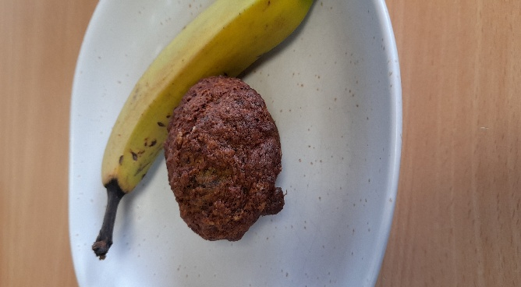

Recipe source: Sandra bernard
Season: any season
Type: dessert
Difficulty: easy
Serves: Serves 12
Fresh from the garden:

Equipment | Ingredients:
  - Muffin tray (12-hole)
  - Muffin paper cases or cooking spray
  - Large mixing bowl
  - Medium mixing bowl
  - Whisk
  - Wooden spoon or spatula
  - Measuring cups and spoons
  - Kitchen scales
  - Fork or potato masher (for bananas)
  - Ice cream scoop or spoon (for portioning batter)
  - Cooling rack
  - Oven mitts
  - 188gr plain flour (replace with GF plain flour)
  - 1 teaspoon baking powder
  - 1 teaspoon baking soda
  - 1/2 teaspoon salt
  - 1 teaspoon ground cinnamon
  - 1/4 teaspoon ground nutmeg
  - 345g mashed bananas (about 4 medium)
  - 85g unsalted butter Melted (replace with Nutellex for DF)
  - 135g packed light or dark brown sugar
  - 1 large egg (replace with EF or 1 tbsp chia seeds and 40 ml water (sit for 10 minutes)
  - 1 teaspoon pure vanilla extract
  - 30ml milk (replace with soy milk)
  - optional: 1 cup chopped chocolate chips

What to do:

- Preheat oven to 220°C. Spray a 12-count muffin pan with nonstick spray or use cupcake liners.
- Whisk the flour, baking powder, baking soda, salt, cinnamon, and nutmeg together in a medium bowl. Set aside. In a large bowl or in the bowl of your stand mixer, mash the bananas. On medium speed, beat or whisk in the melted butter, brown sugar, egg, vanilla extract, and milk. Pour the dry ingredients into the wet ingredients, then beat or whisk until combined. If adding nuts or chocolate chips, fold them in now. Batter will be thick.
- Spoon the batter into liners, filling them all the way to the top. Bake for 5 minutes at 220°C, then, keeping the muffins in the oven, reduce the oven temperature to 175°C. Bake for an additional 16–18 minutes or until a toothpick inserted in the centre comes out clean. The total time these muffins take in the oven is about 21–23 minutes, give or take.
- (For mini muffins, bake 12–14 total minutes at 177°C. Allow the muffins to cool for 5 minutes in the muffin pan, then transfer to a wire cooling rack to continue cooling.
- Muffins stay fresh covered at room temperature for a few days or in the refrigerator for up to 1 week.

⚠️ Allergy & Diet Information
Icons
🌾 🥛 🥚 🥜❌ ⚠️
Allergen Notes
- Gluten: ❌ Contains wheat flour
- Dairy: ❌ Contains milk, butter
- Eggs: ❌ Contains eggs
- Nut-free: ✅ Unless nuts or nut products are added

