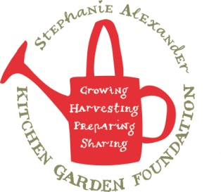
Aussie Garden Pasta Salad
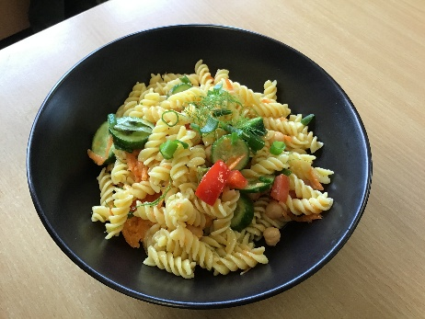

Recipe source: Sandra Bernard
Season: Summer/Autumn
Type: Salad
Difficulty: Easy
Serves: Serves 30 to taste
Fresh from the garden:

Equipment | Ingredients:
  - Large pot
  - Colander
  - Large mixing bowl
  - Knife & board
  - 1kg pasta
  - 2 cups cherry tomatoes
  - 210gr chickpeas (1/2 can), drained and rinsed
  - 2 cucumbers
  - 2 cups grated carrot
  - Fresh basil, parsley and mint leaves
  - 240ml olive oil
  - 1 - 1.5 tbsp Dijon mustard
  - 3 garlic cloves minced
  - 60ml lemon juice
  - Salt & pepper

What to do:

Cook the pasta
- Cook the normal pasta in one pot and the GF pasta in a separate pot.
- Drain both when soft and put them in separate bowls to cool.
Prepare the vegetables
- Wash and chop all vegetables.
- Keep some vegetables aside for GF students so you can mix them with GF pasta.
Prepare the herbs
- Chop fresh herbs (like parsley or basil).
- Keep some aside for GF students to mix in separately.
Combine pasta, vegetables, and herbs
- Mix normal pasta with the normal vegetables and herbs using one set of utensils.
- Mix GF pasta with the reserved vegetables and herbs using separate utensils.
Make the dressing
- Mix olive oil, Dijon mustard, garlic, lemon juice, salt, and pepper in a bowl.
- Keep a little dressing aside for GF pasta so it doesn’t touch the normal pasta.
Dress the salad
- Pour dressing over normal pasta and gently toss.
- Pour the reserved dressing over GF pasta and gently toss with separate utensils.
Serve
- Put tasting portions into small cups or plates.
- Make sure GF portions do not touch the normal pasta. TURN THE PAGE

Allergy Information:
Contains: Gluten (wheat – pasta)

Allergy Notes:
• Use gluten-free pasta if required

