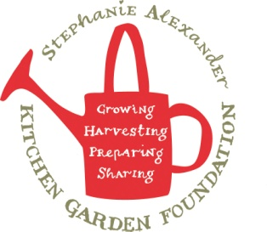
Apple Cake
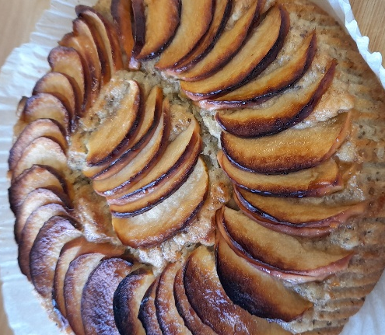

Recipe source: Sandra bernard
Season: Autumn
Type: Baking / Dessert
Difficulty: easy
Serves: Serves 30 to taste
Fresh from the garden: Apple, lemon, eggs from chicken

Equipment | Ingredients:
  - Mixing bowls
  - Whisk
  - Measuring jug
  - Kitchen scales
  - Sieve
  - Peeler
  - Apple corer or knife
  - Chopping board
  - Small saucepan or microwave
  - safe bowl
  - Slice tray or baking tray (approx. 20 x 30 cm)
  - Baking paper
  - Cooling rack
  3-4 apples + lemon juice
  3 eggs (replace with 3 tbsp chia seed and 145ml water)
  250 g granulated sugar
  215 g all purpose flour
  2 tsp baking powder
  1 tsp vanilla sugar (or vanilla extract)
  1 pinch salt
  100 g butter
  200 ml milk
  4 tbsp brown sugar
  1 tsp ground cinnamon

What to do:
- Preheat oven to 175°C. Grease the sides of the baking tray and line the bottom with baking paper.
- Peel and core the apples and cut them into medium slices and mix with lemon juice to coat.
- Whisk the eggs and sugar together. Sift in the flour, baking powder and vanilla and stir until you have a smooth batter.
- Melt the butter and stir in the milk. Add this milk mixture to the cake batter, stirring until smooth.
- Spread the cake batter evenly in the spring from and arrange the apple slices on top in circles, letting them sink into the batter on their own. Sprinkle the top with brown sugar and cinnamon.
- Bake for about 45 minutes until the cake is firm. You can test the centre with a toothpick – no batter should stick to the toothpick when the cake is done.
- Let the cake cool before slicing
Allergen Notes
- Gluten: ❌ Contains wheat flour
- Dairy: ❌ Contains butter and milk
- Eggs: ❌ Contains egg

