
Apple Oat Slice
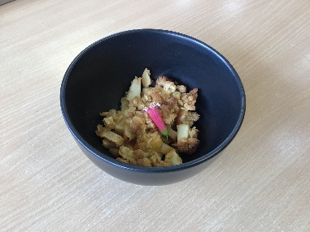

Recipe source: Sandra Bernard
Season: Autumn, Winter
Type: Sweet Baking
Difficulty: Easy
Serves: Serves 30 to taste
Fresh from the garden: Apples

Equipment | Ingredients:
  - Mixing bowl
  - Baking tray
  - Baking paper
  - Spoon
  - Oven
  Filling
  - 5–6 medium apples (about 900 g–1 kg)
  - 2 tbsp sugar
  - 1 tsp cinnamon (optional)
  - 1 tbsp lemon juice
  Crumble Topping
  - 1½ cups plain flour
  - 1 cup rolled oats
  - ¾ cup brown sugar
  - 150 g butter (cold, cubed)

What to do:
- Preheat oven to 180°C.
- Peel and slice or dice apples.
- Toss apples with sugar, cinnamon and lemon.
- Spread apples evenly in tray.
- Rub butter into flour, oats and sugar until crumbly.
- Sprinkle crumble evenly over apples.
- Bake 30–35 minutes until golden.
- Cool slightly before cutting into 30 small squares.
Bake in a large rectangular tray (approx. 30 x 20 cm)
Allergy Notes:
Use gluten-free flour and certified GF oats if needed
Dairy-free butter substitute can be use

