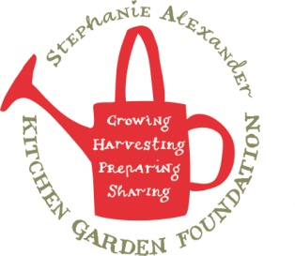
Honey Popcorn with Lemon Myrtle
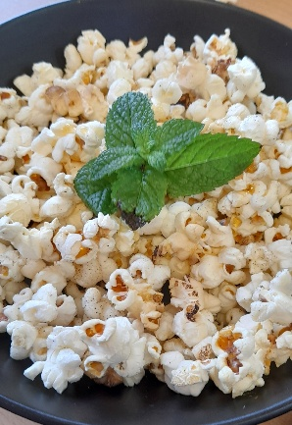

Recipe source: Sandra Bernard
Season: All seasons
Type: snack
Difficulty: Easy
Serves: Serves 30 to taste
Fresh from the garden: Lemon myrtle

Equipment | Ingredients:
  - Large pot with lid (or popcorn machine)
  - Large mixing bowl
  - Small saucepan
  - Baking tray + baking paper
  - Spoon
  - 300gr Popcorn kennel
  - 180ml Coconut oil
  - 60gr Honey
  - 15gr salt
  - 1 Tbsp dried lemon myrtle
  - 30gr caster sugar

What to do:
- In a deep saucepan, melt the coconut oil on a medium high heat.
- Once the oil is melted, add the corn kernels and cover immediately as they will start popping.
- When popped, dust popcorn with the lemon myrtle and stir through the honey.
- Serve sprinkled with the caster sugar

