
Carrot and Ginger Soup
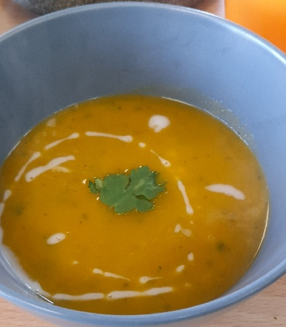

Recipe source: Sandra Bernard
Season: Autumn / Winter
Type: Soup
Difficulty: Easy
Serves: Serves 30 to taste
Fresh from the garden: Carrot, herbs

Equipment | Ingredients:
  - Large stock pot
  - Blender or stick blender
  - Knife & chopping board
  - Ladle
  - 3 tablespoon extra-virgin olive oil
  - 1½ medium yellow onion, chopped
  - 1½ teaspoon sea salt
  - 6 garlic cloves, smashed
  - 6 carrots, roughly chopped
  - 3 teaspoon grated fresh ginger
  - 2 tablespoon apple cider vinegar
  - 6 cups vegetable broth
  - Freshly ground black pepper
  - Coconut cream and herbs for garnish

What to do:
- Heat the oil in a large pot over medium heat. Add the onions, salt and pepper and cook until softened, stirring occasionally, about 8 minutes. Add the smashed garlic cloves (they’ll get blended later) and carrots to the pot and cook 8 minutes more, stirring occasionally.
- Stir in the ginger, apple cider vinegar, and broth. Bring to a boil, then reduce the heat and simmer for 30 minutes.
- Let cool slightly and transfer to a blender. Blend until smooth. If your soup is too thick, add a little water.
- Serve with a drizzle of coconut cream and herbs, if desired.

Allergen Notes
- Gluten: ✅ Gluten-free
- Dairy: ✅ Dairy-free
- Eggs: ✅ Egg-free
- Vegan: ✅ Yes
- Allergy alert: Check stock is gluten-free

