
Anzac biscuits
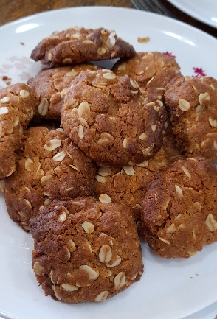

Recipe source: Sandra Bernad
Season: Anzac day
Type: Baking
Difficulty: Easy
Serves: Serves 30 to taste
Fresh from the garden:

Equipment | Ingredients:
  - Large mixing bowl
  - Small saucepan
  - Baking trays
  - Baking paper
  - Spoon or scoop
  - 225 gr plain flour, sifted
  - 135gr rolled oats
  - 165gr caster sugar
  - 75gr desiccated Coconut
  - 225g unsalted Butter
  - 3 tbsp golden syrup
  - 2 tbsp water
  - 3/4 tsp bicarbonate soda

What to do:
- Preheat oven
170°C (fan-forced). Line trays with baking paper.
- Mix dry ingredients
Combine flour, oats, sugar and coconut in a bowl.
- Melt butter mixture
In saucepan, melt butter and golden syrup over low heat.
- Activate bicarb
Mix bicarb with water, add to butter mixture (it will foam).
- Combine
Pour wet mixture into dry ingredients and mix well.
- Shape biscuits
Roll small balls (about 1 tablespoon / 30 g) and place on tray.
Flatten slightly.
- Bake
Bake 10–12 minutes until golden.
- Cool
Allow to firm up on tray before moving.
Allergen Notes
- Gluten: ❌ Contains wheat (flour, oats unless GF) – replace with GF flour, GF oats
- Dairy: ❌ Contains butter – replace with plant-based margarine
- Eggs: ✅ Egg-free
- Vegetarian: ✅ Yes
- Vegan option: Replace butter with plant-based margarine

